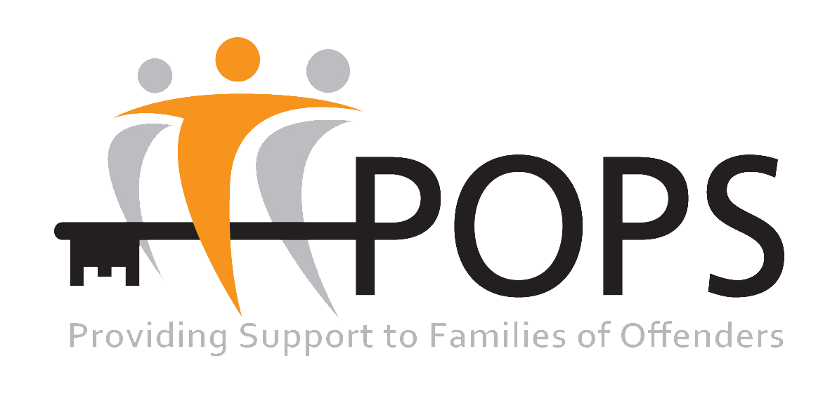

Job Description

Job Title: Women’s Support Worker

Salary: £13,005 per Annum (£24,394.50 Full Time Equivalent)

Hours: xx Hours per Week

Location: Farida Women’s Centre, Oldham

POPS recognises the positive value of diversity, promotes equality and challenges discrimination.

As this role involves working with women from Black, Asian and Minority Ethnic (BAME) communities, we welcome and encourage job applications from people of all backgrounds. We particularly welcome applications from disabled and Black, Asian and Minority Ethnic (BAME) candidates.

PURPOSE OF THE POST
The Women’s Support Worker will be responsible for the delivery of support service for women subject to Probation supervision, many of whom will have multiple or complex needs.

The Women’s Support Worker will work closely with Probation Practitioners, the engage women subject to Probation supervision, to undertake support and deliver a range of interventions to address and resolve identified issues and develop strategies to bring about positive changes to their lives.

ACCOUNTABILITY

POPS’ Women’s Support Worker Lead

MAIN TASKS

- To manage and accept mandated referrals from Probation Service

- Work alongside other agencies who are part of the Greater Manchester Integrated Rehabilitation Services in Oldham, area e.g., Accommodation providers,

- To deliver advice, support and interventions to women subject to Probation supervision who are resident in the Oldham area.

- Meet contractual KPIs.

- Provide timely and accurate information to Probation Practitioners

- Provide culturally appropriate support for BAME Women

• To undertake 1-1 assessments with all women with referred the Farida Women Centre, within the timescales set by The Probation Service national standards

- Carry out needs assessments with each service user using Outcome Star Assessment Tool.

- Produce and agree an individual action plan for each service user

- To work with each service user to achieve agreed goals, milestones and outcomes by providing a diverse and bespoke range of interventions and support.

- Carry out home visits to service users where required (subject to risk assessment information)

• Co-ordinate service user referrals to partner agencies for specialist interventions, support or activities (i.e., Recovery Services).

• Contribute to MAPPA meetings, Child Protection Meetings, Core Groups and Care Planning meetings by forwarding reports if and when required.

- Maintain up to date case records using Probation service and In House electronic CRM systems.

- Produce a minimum of one written case study per month.

- Work on flexible basis, some evening or weekend work will be required on a rota basis

- Undertake any other duties as requested by POPS’ line manager.

Person Specification

The following are the minimum essential criteria, which will be used to assess your application form. Please ensure that you cover the criteria in your answers, including all your experience both paid and unpaid.

Criteria | Description | Value
QUALIFICATIONS | Literate and numerate to Maths and English L2 or equivalent. | Desirable
EXPERIENCE | Experience of working in a team and also of using own initiative with limited supervision.  Experience of working with women with offending behavior and complex needs,  Experience of working with Women from BAME communities  Experience of working with individuals in the criminal justice system | Essential  Essential  Desirable  Desirable
SKILLS AND ABILITIES | Ability to initiate, build and develop sustainable relationships with women with complex needs  Good communication skills.  Ability to give clear and accurate information  Numerate and Literate  ICT literate, able to use a range of Microsoft Office and associated packages. | Essential  Essential  Essential  Essential  Essential
WORK RELATED CIRCUMSTANCES | Availability to work flexible hours  Driving license and access to a car | Essential  Essential
PERSONAL QUALITIES | Willingness Undertake training and development activities to meet the changing requirements of the project  Empathy  Flexible, adaptable  Work as part of a team  A commitment to implement equal opportunities  Uphold the POPS ethos, vision and values | Essential  Essential  Essential  Essential  Essential  Essential

