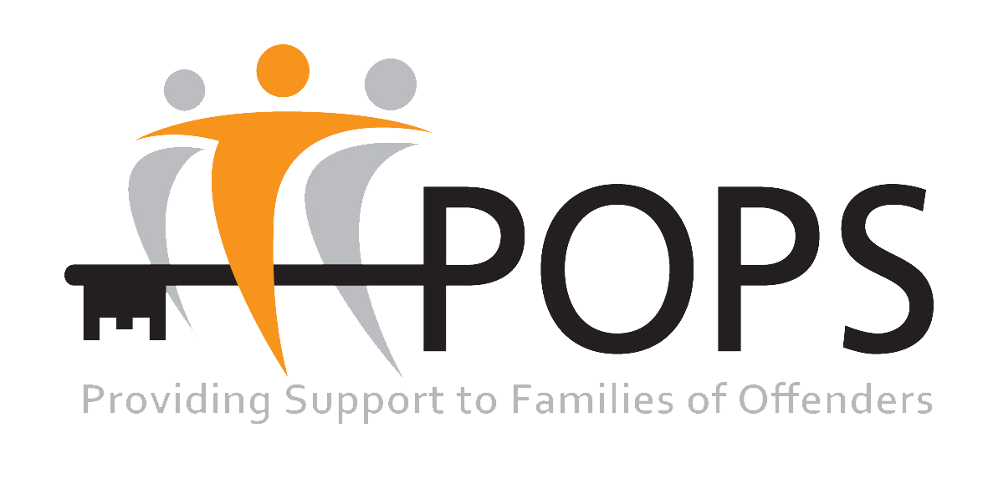

Job Description

Job Title: Lead Women’s Support Worker

Salary: £29,250 per Annum

Hours per Week: 37.5 hours (Monday to Friday 9am-5pm)
Location: POPS’ Women’s Centre, Oldham

POPS’ Women Centre in Oldham is part of the Greater Manchester Women Support Alliance. (GMWSA) Together with other providers in the GMWSA, POPS delivers gender specific services and interventions to support women in the criminal justice system and women with complex needs.

POPS recognises the positive value of diversity, promotes equality and challenges discrimination.

This role involves working with women from diverse communities, we welcome and encourage job applications from people of all backgrounds. We particularly welcome applications from disabled and Black, Asian and Minority Ethnic (BAME) candidates.

NB: as this role lawfully provides services specific to women, this role is exempt from the Equality Act 2010, as there is a requirement for all members of its staff working at the women centre to be female.

PURPOSE OF THE POST:

The Lead Women’s Support Worker will be responsible for overseeing and the delivery of gender specific support service for women subject to Probation supervision, many of whom have multiple or complex needs.

The Lead Women’s Support Worker will work closely with Probation Practitioners, the engage women subject to Probation supervision. Role includes delivering a range of interventions directly to the women who attend the centre and maintaining working relationships with partner agencies and specialist services, to coordinate and rota co-location of a multi-disciplinary team at POPS’ women’s centre in Oldham.

ACCOUNTABILITY

POPS’ Operations Manager

TASKS:

- Supervise one member of staff and volunteers at POPS’ Women centre.

- Ensure POPS’ Women centre is open and staffed Monday – Friday 9am – 5pm. (occasionally 7pm on Wednesday if requested by probation service)

- Contract management, ensuring all KPI’s and compliance measures are met.

- Oversee the coordination of the service delivery for mandated referrals of women from Probation Service

- Work closely with Probation Service in Oldham area.

- Work proactively to develop and maintain productive working relationships with partner agencies and specialist services in the locality.

- Coordinate and rota co-location of a multi-disciplinary team/specialist agencies to attend POPS’ women’s centre.

• Undertake 1-1 assessments with all women with referred to POPS’ Women Centre, within the timescales set by the Probation Service national standards

- Produce and agree an individual action plan for each woman.

- Work with each service user to achieve agreed goals, milestones and outcomes.

• Attendance at meetings where required, e.g. contract and monitoring meetings, specialist, MAPPA; Core Groups; Care Planning meetings

- Ensure up to date case records are maintained by POPS’ staff, using Probation service and POPS’ In House electronic CRM systems.

- Provide timely and accurate information to Probation Practitioners

- Produce monthly statistical and narrative reports when required.

- Produce a minimum of one written case study per month.

- Work on flexible basis to meet delivery requirements of the contract.

- Undertake training as mandated by POPS and the requirement of commissioned contracts

- Undertake any other duties as requested by POPS’ line manager.

Person Specification

The following are the minimum essential criteria, which will be used to assess your application form. Please ensure that you cover the criteria in your answers, including all your experience both paid and unpaid.

Criteria | Description | Value
QUALIFICATIONS | Literate and numerate to Maths and English L2 or equivalent. | Essential
EXPERIENCE | Experience of working with limited supervision.  Experience of initiating, planning, and developing areas of work.  Experience of producing detailed written reports  Experience of working to, and meeting deadlines  Experience of working with women with complex needs.  Experience of working collaboratively with multiple agencies  Experience of working with women who are subject to Probation Supervision  Experience of delivering small group sessions  Experience of supervising staff | Essential  Essential  Essential  Essential  Essential  Essential  Desirable  Desirable  Desirable
SKILLS AND ABILITIES | Able to maintain accurate and confidential records  Ability to initiate, build and develop sustainable relationships with women with complex needs  Ability to engage effectively with outside agencies  Excellent listening and communication skills.  Numerate and Literate  ICT literate, able to use a range of Microsoft Office and associated packages. | Essential  Essential  Essential  Essential  Essential  Essential
WORK RELATED CIRCUMSTANCES | Availability to work flexibly.  Driving license and access to a car as travel to meetings maybe required  Knowledge of Probation and Prison system | Essential  Essential  Desirable
PERSONAL QUALITIES | Commitment to undertake mandatory training and development activities.  Work as part of a team  A commitment to implement equal opportunities.  Uphold the POPS ethos, vision and values | Essential  Essential  Essential  Essential

